**Experiment No. 4**

PART A

(PART A: TO BE REFFERED BY STUDENTS)

A.1 Aim: **User Interface Design Phase 1**

**A.2 Prerequisite:**

Knowledge of java and android app.

**A.3 Outcome:**

After successful completion of this experiment students will be able to

1. Make screen layout for android app.
2. Know the idea of sdk manager and AVM.
3. Understand the uses of tools available for user interface.

**A.4 Theory:**

The basic building block for user interface is a **View** object which is created from the View class and occupies a rectangular area on the screen and is responsible for drawing and event handling. View is the base class for widgets, which are used to create interactive UI components like buttons, text fields, etc.

The **ViewGroup** is a subclass of **View** and provides invisible container that hold other Views or other ViewGroups and define their layout properties.

At third level we have different layouts which are subclasses of ViewGroup class and a typical layout defines the visual structure for an Android user interface and can be created either at run time using**View/ViewGroup** objects or it can be declared as layout using simple XML file **main_layout.xml** which is located in the res/layout folder of the project.

**Here more about creating GUI based on layouts defined in XML file. A layout may contain any type of widgets such as buttons, labels, textboxes, and so on. Following is a simple example of XML file having LinearLayout:**

<?xml version="1.0" encoding="utf-8"?>

<LinearLayout xmlns:android="http://schemas.android.com/apk/res/android"

android:layout_width="fill_parent"

android:layout_height="fill_parent"

android:orientation="vertical" >

<TextView android:id="@+id/text"

android:layout_width="wrap_content"

android:layout_height="wrap_content"

android:text="This is a TextView" />

<Button android:id="@+id/button"

android:layout_width="wrap_content"

android:layout_height="wrap_content"

android:text="This is a Button" />

<!-- More GUI components go here -->

</LinearLayout

There are many more types of layout. Some of which are listed below:

Linear Layout

Absolute Layout

Table Layout

Frame Layout

Relative Layout

**UI screen components**

A typical user interface of an android application consists of action bar and the application content area.

Main Action Bar

View Control

Content Area

Split Action Bar

**Understanding Screen Components**

The basic unit of android application is the activity. A UI is defined in an xml file. During compilation, each element in the XML is compiled into equivalent Android GUI class with attributes represented by methods.

**View And Viewgroups**

An activity is consist of views. A view is just a widget that appears on the screen. It could be button e.t.c. One or more views can eb grouped together into one GroupView. Example of ViewGroup includes layouts.

PART B

(PART B: TO BE COMPLETED BY STUDENTS)

**(Students must submit the soft copy as per following segments within two hours of the practical. The soft copy must be uploaded on the Blackboard or emailed to the concerned lab in charge faculties at the end of the practical in case the there is no Black board access available)**

|  |  |
| --- | --- |
| Roll No. B046 | Name: Pranav Joshi |
| Program: B.tech Computer | Division: B |
| Semester: IV | Batch : B3 |
| Date of Experiment: 5-2-15 | Date of Submission: 26-2-15 |
| Grade : |  |

B.1 Task to be done:

**1)** Paste Source code of .xml and .java files in this section along with output.

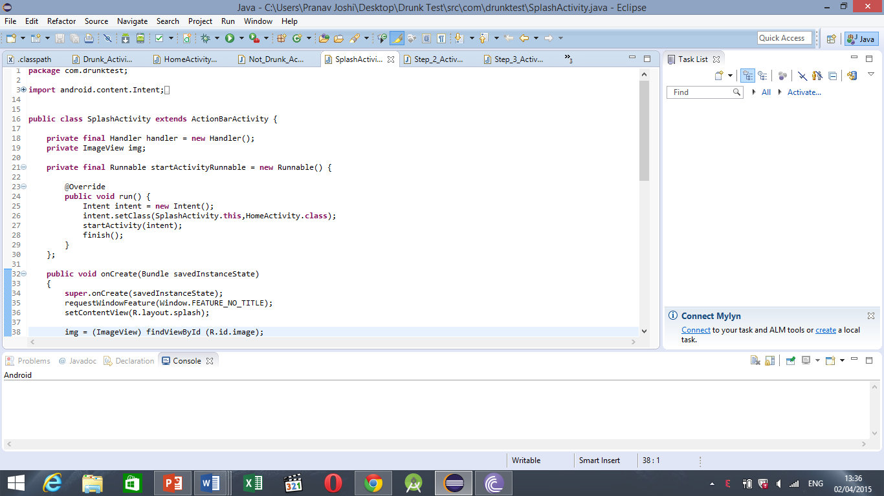

**<projectDescription>**

**<name>Drunk Test</name>**

**<comment></comment>**

**<projects>**

**</projects>**

**<buildSpec>**

**<buildCommand>**

**<name>com.android.ide.eclipse.adt.ResourceManagerBuilder</name>**

**<arguments>**

**</arguments>**

**</buildCommand>**

**<buildCommand>**

**<name>com.android.ide.eclipse.adt.PreCompilerBuilder</name>**

**<arguments>**

**</arguments>**

**</buildCommand>**

**<buildCommand>**

**<name>org.eclipse.jdt.core.javabuilder</name>**

**<arguments>**

**</arguments>**

**</buildCommand>**

**<buildCommand>**

**<name>com.android.ide.eclipse.adt.ApkBuilder</name>**

**<arguments>**

**</arguments>**

**</buildCommand>**

**</buildSpec>**

**<natures>**

**<nature>com.android.ide.eclipse.adt.AndroidNature</nature>**

**<nature>org.eclipse.jdt.core.javanature</nature>**

**</natures>**

**</projectDescription>**

<LinearLayout xmlns:android="http://schemas.android.com/apk/res/android"

android:id="@+id/main"

android:layout_width="fill_parent"

android:layout_height="fill_parent"

android:gravity="center_horizontal"

android:padding="10dp"

android:orientation="vertical"

android:background="@android:color/black">

<TextView

android:layout_width="wrap_content"

android:layout_height="wrap_content"

android:layout_gravity="center"

android:fadingEdge="horizontal"

android:focusable="true"

android:focusableInTouchMode="true"

android:freezesText="true"

android:gravity="center"

android:padding="5dip"

android:shadowColor="#FFFFFF"

android:shadowDx="4"

android:shadowDy="4"

android:shadowRadius="4"

android:textColor="#FF0000"

android:textSize="55sp"

android:textStyle="bold"

android:text="YOU ARE DRUNK !"

/>

<Button

android:id="@+id/exit_button"

android:layout_width="wrap_content"

android:layout_height="wrap_content"

android:onClick="onClick"

android:background="@color/search_button_blue"

android:layout_margin="10dp"

android:gravity="center"

android:layout_gravity="center_horizontal"

android:paddingLeft="40dp"

android:paddingRight="40dp"

android:text="Exit"

android:textColor="@android:color/white" />

</LinearLayout>

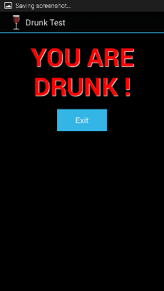

<RelativeLayout xmlns:android="http://schemas.android.com/apk/res/android"

xmlns:tools="http://schemas.android.com/tools"

android:layout_width="match_parent"

android:layout_height="match_parent"

android:background="@android:color/black"

>

<ImageView

android:id="@+id/image"

android:layout_width="wrap_content"

android:layout_height="wrap_content"

android:src="@drawable/wine"

android:layout_centerInParent="true"

/>

</RelativeLayout>

<ScrollView xmlns:android="http://schemas.android.com/apk/res/android"

android:layout_width="fill_parent"

android:layout_height="fill_parent"

android:background="@android:color/black" >

<LinearLayout

android:layout_width="fill_parent"

android:layout_height="wrap_content"

android:background="@android:color/black"

android:orientation="vertical"

android:paddingLeft="10dp" >

<TextView

android:layout_width="wrap_content"

android:layout_height="wrap_content"

android:layout_gravity="center"

android:layout_marginBottom="20dp"

android:fadingEdge="horizontal"

android:focusable="true"

android:focusableInTouchMode="true"

android:freezesText="true"

android:gravity="center"

android:shadowColor="#FF0000"

android:shadowDx="4"

android:shadowDy="4"

android:shadowRadius="4"

android:text="MCQ test"

android:textColor="@android:color/white"

android:textSize="20sp"

android:textStyle="bold" />

<LinearLayout

android:layout_width="match_parent"

android:layout_height="wrap_content"

android:orientation="horizontal"

android:padding="50dp" >

<ImageButton

android:layout_width="wrap_content"

android:layout_height="wrap_content"

android:src="@drawable/color_image" />

</LinearLayout>

<RadioGroup

android:id="@+id/rGroup"

android:layout_width="fill_parent"

android:layout_height="wrap_content"

android:orientation="vertical" >

<RadioButton

android:id="@+id/opt0"

android:layout_width="wrap_content"

android:layout_height="wrap_content"

android:checked="false"

android:text=" a. More green less blue"

android:textColor="@android:color/white" />

<RadioButton

android:id="@+id/opt1"

android:layout_width="wrap_content"

android:layout_height="wrap_content"

android:text=" b. Boundry blue center green"

android:textColor="@android:color/white" />

<RadioButton

android:id="@+id/opt2"

android:layout_width="wrap_content"

android:layout_height="wrap_content"

android:text=" c. Both a and b"

android:textColor="@android:color/white" />

<RadioButton

android:id="@+id/opt3"

android:layout_width="wrap_content"

android:layout_height="wrap_content"

android:text=" d. Blue boundry"

android:textColor="@android:color/white" />

</RadioGroup>

<Button

android:id="@+id/submit_button"

android:layout_width="wrap_content"

android:layout_height="wrap_content"

android:layout_gravity="center_horizontal"

android:layout_margin="10dp"

android:background="@color/search_button_blue"

android:gravity="center"

android:onClick="onClick"

android:paddingLeft="40dp"

android:paddingRight="40dp"

android:text="Done"

android:textColor="@android:color/white" />

</LinearLayout>

</ScrollView>

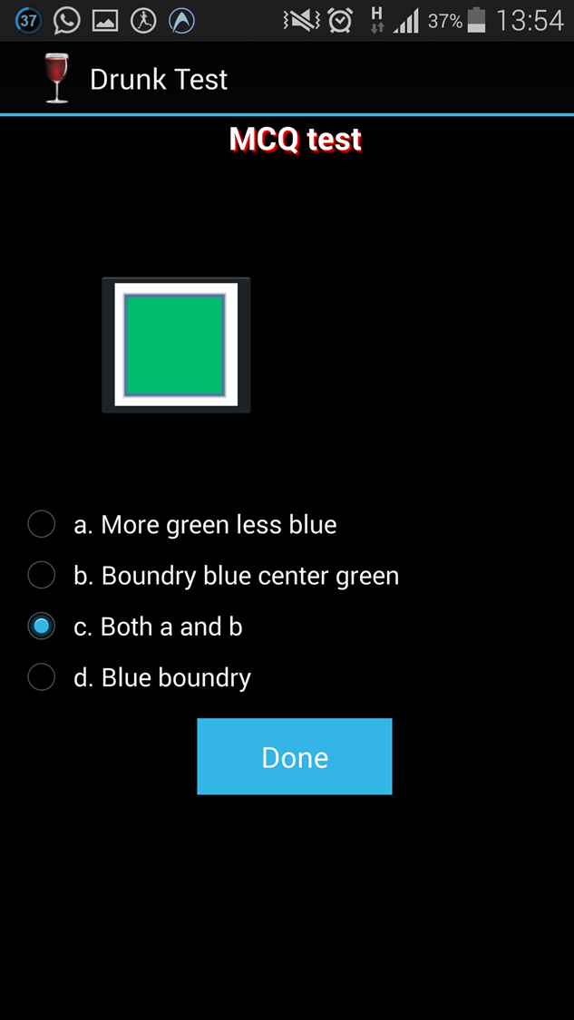

B.3 Conclusion:

Hence we successfully made screen layout of the app, used xml infrastructure and utilized various android resources to develop the application.